TOA ASSIGNMENT #1

SECTION F

|  |  |  |
| --- | --- | --- |
| SR # | NAME | ROLL # |
| 1 | Mehdi Raza Rajani | K163904 |
| 2 | Tahir Raza Hemani | K163905 |
| 3 | Moazzam Maqsood | K163868 |

# DFA 1:

**DFA for the language {w : w contains 01 an odd number of times} over the alphabet { 0 , 1 }.**

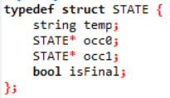

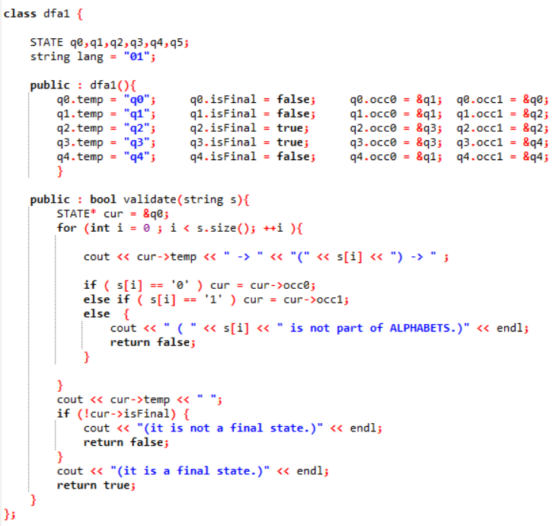

**DFA:**

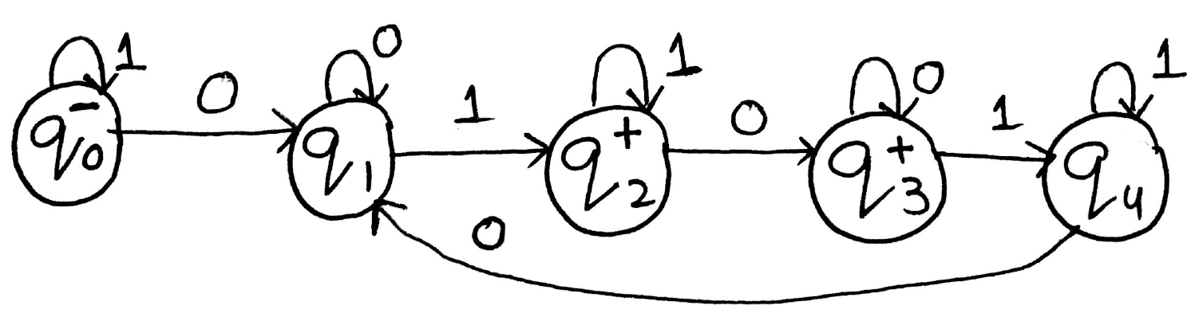

**TEST CASES:**





# DFA 2:

**DFA for the language of words over the alphabet { 0 , 1 } that contain the substring 01101.**



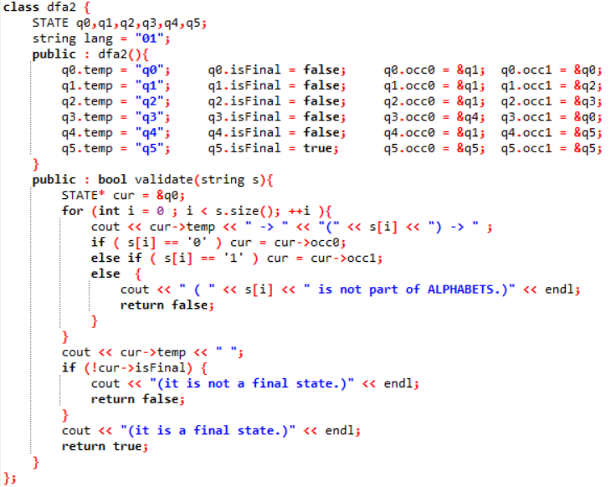

**DFA:**

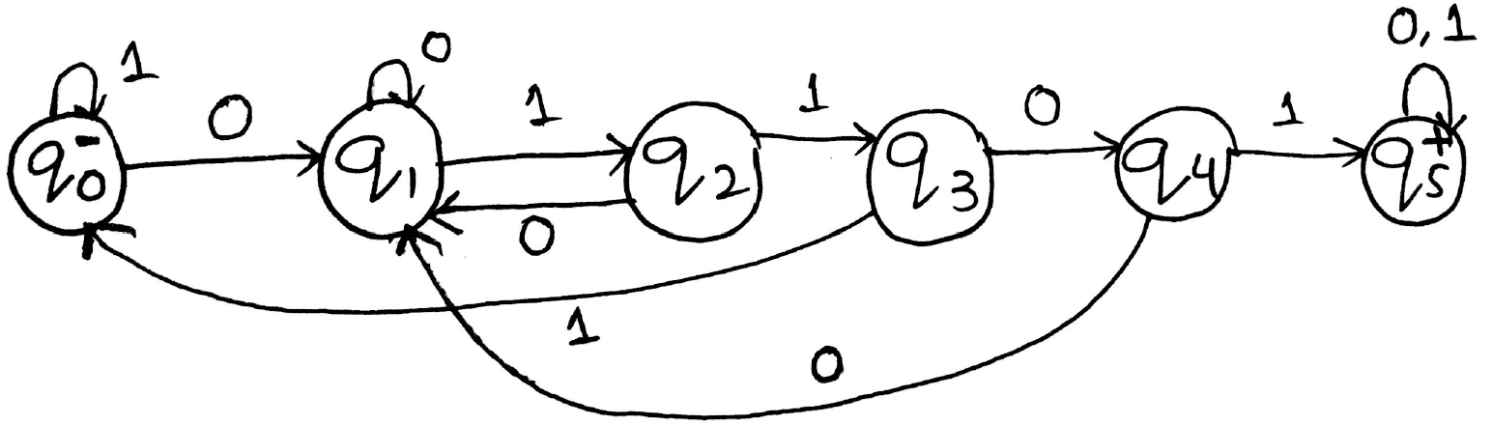

**TEST CASES:**





# DFA 3:

**DFA for the language {w : w is an integer at least 23} over the alphabet { 0 , 1 , . . . , 9 }. Words in this language should not have max three leading 0s.**

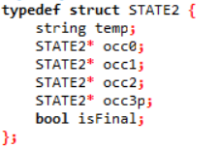

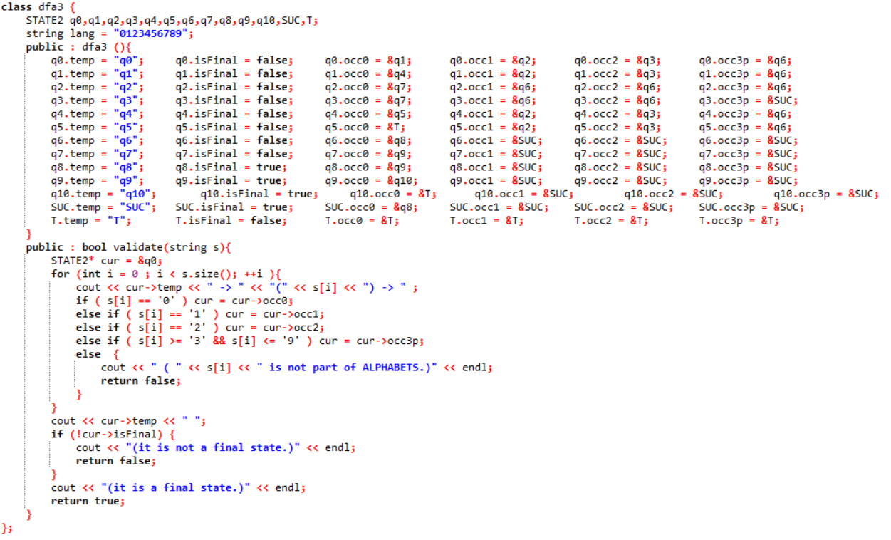

**DFA:**

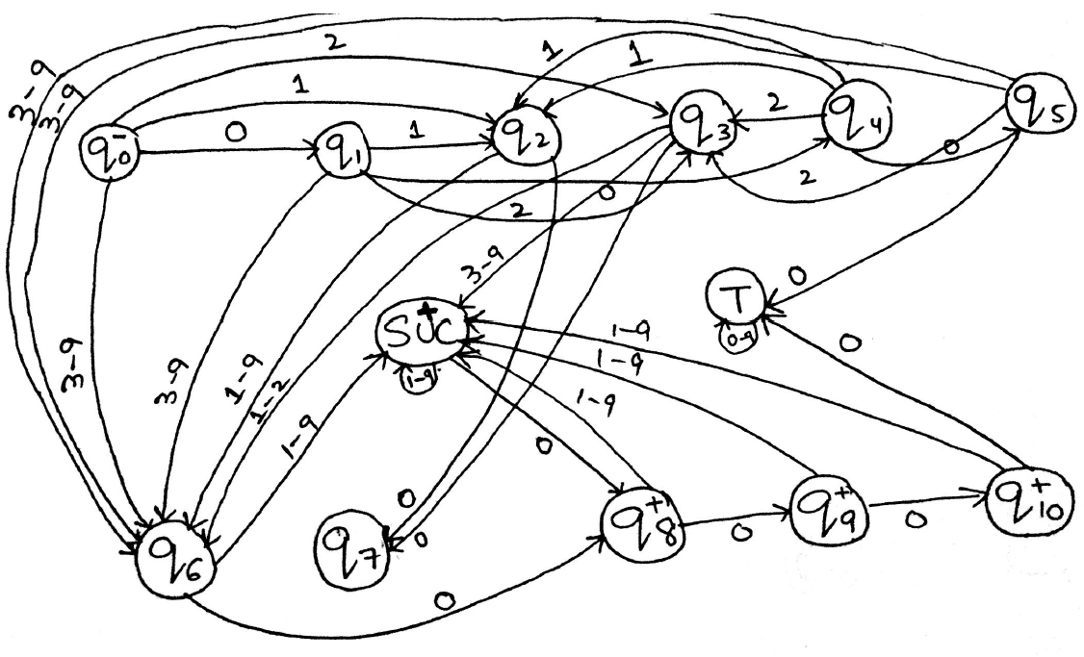

**TEST CASES:**

 

# DFA 4:

**S = { 0 , 1 } , L = {w e S| |w| mod 4 = 1}.**



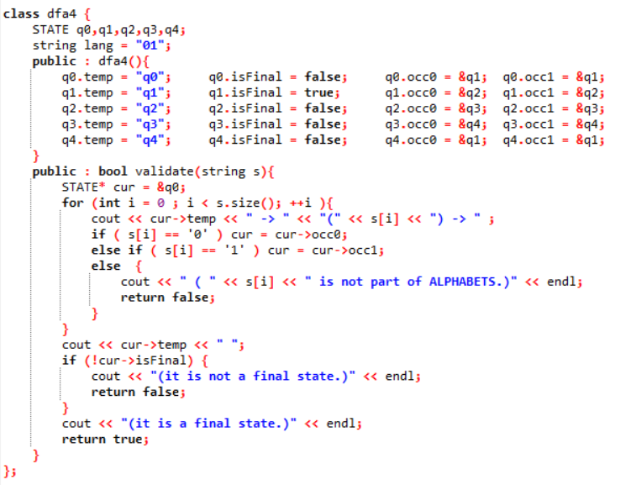

**DFA:**

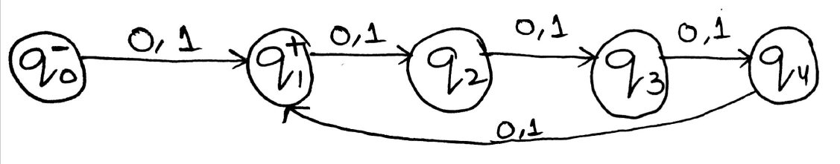

**TEST CASES:**





# DFA 5:

**S = { 0 , 1 } , L = {w e S| w mod 4 = 1}.**



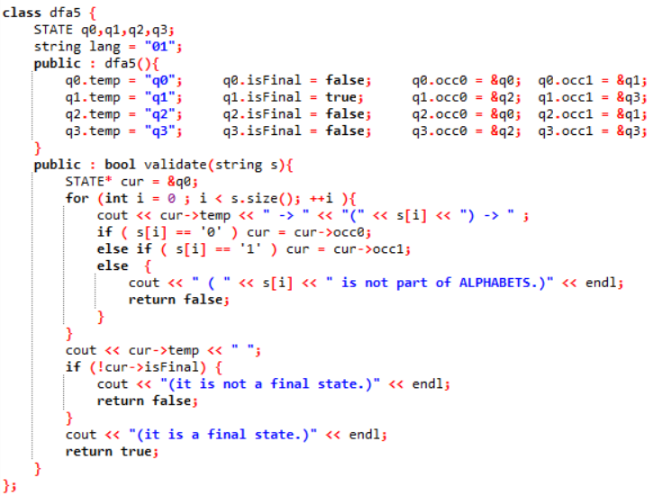

**DFA:**

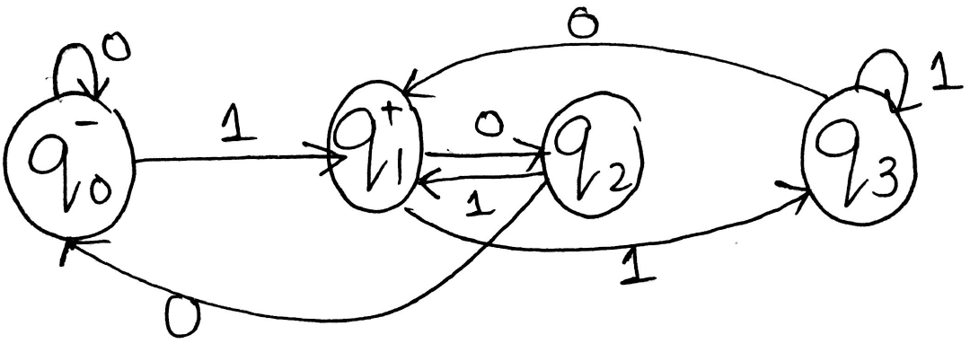

**TEST CASES:**

 